Assist – Volunteer Application Form
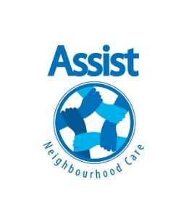

Personal Details
Full name
Date of Birth
What kind of volunteering are you interested in?

Contact Details
Address
Telephone Number(s)
E-mail

Next of Kin
Full name
Relationship to you
Address
Telephone Number(s)
E-mail
How did you hear about Assist?
Assist – Volunteer Application Form


Interests/Skill/Experience
Please use the space below to describe what type of Volunteering you are interested in and why you are thinking of volunteering with Assist.

Please list any skills/experience you think might be relevant to your Volunteering (e.g. driving, first aid courses, related employment, chess player, musical talents etc)

Availability
 | Mornings | Afternoons | Evenings
Weekdays
Weekends
Occasionally

General Information
Are there any restrictions to the type of Volunteering activities you could undertake due to health or disability issues?

Assist – Volunteer Application Form


Have you any medical needs or allergies you need to inform us about?

Have you ever been convicted of any criminal offence, or subject to any current criminal proceedings? If yes, please provide further details and be aware that this will be treated as confidential.

References
Please provide two referees who must be over 18 years old, not related to you, and have known you for more than two years.
Name
Relationship to you
Occupation
Telephone
Address
Email
Name
Relationship to you
Occupation
Telephone
Address
Email
[For office use only: Date references sent: ___________ Date references received:________________ ]
Assist – Volunteer Application Form

Monitoring
Assist is partially supported by a Manchester City Council Grant, for submit quarterly monitoring. The following questions relate to this monitoring, are confidential and will not be linked to your name or details.

Employment Status
Employed Full Time |  | Employed Part Time
Retired |  | Registered Unemployed
Student |  | Signed off work
Other |  | Do not wish to disclose

Ethnic Background
White British |  | Asian British
White Irish |  | Asian Pakistani/Indian
White (other) |  | Asian Other
Black British |  | Eastern European
Black Caribbean |  | Chinese
Black (other) |  | Other

How would you describe your Gender? (M/F/NB, etc.)

Volunteer Agreement
I understand that Assist may need to carry out a DBS check (formerly CRB) before I can be approved as a volunteer. I also understand that all information given on this form is confidential, will not be passed on to any third parties, and that I can request to withdraw this form and information at any time.
For volunteers involved in a driving role, I agree to take responsibility for informing my insurance company of this change, and confirm that I have an in date licence, MOT, Road Tax and insurance policy.
I confirm I have read and understood the Volunteer Pack.
Signature |  | Date

I have

